Between the ages of 3-8, a child's brain is 2 1/2 times more active than ever and 50% of the calories consumed, go into making brains grow and learn. Children inherit more than our genes, they inherit our lifestyle. Children today are overfed, undernourished, and dehydrated. Our bodies are designed to be nourished with fresh fruits and vegetables and to be hydrated with water, not juice. The question to ask yourself is, do you feed your children or do you nourish them?
Dear Parents-- It's TIME 2 TALK...
"Building Children's Brains"
Building children's brains isn't "brain surgery"
but it is important to know all about the brain.
​
The Brain
The brain develops from bottom up and from top to bottom.
​
- The base of the brain controls breathing, heartbeat, and automatic responses (stress/fear).
- The cerebellum involves movement, focus, and attention.
- The limbic system controls emotion.
- The cortex cerebrum is the thinking area of the brain and it doesn't develop fully until adolescence.
​
​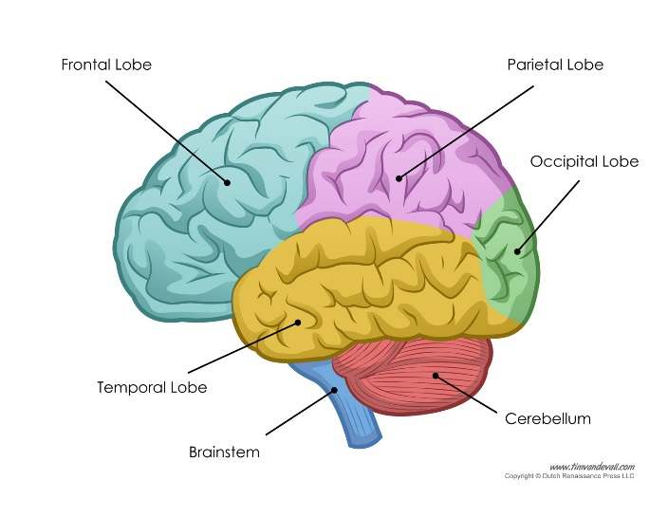
We remember things in the part of the brain where we first learned it. So the more senses that are involved, the better the retention of material. Seeing it, feeling it, hearing it, touching it, and tasting it are all important in the learning process. Every child is born with a range of possibilities of about 40 IQ points. Good experiences maximize those IQ points. In the preschool years, we help the brain neurons to connect. By the end of preschool, the brain should look like a roadmap, with lots of pathways for ideas to travel.

What do we do to develop these neurons?
​
Giving children lots of NEW opportunities and NEW experiences outside their routine, helps the brain to grow in many ways. Observing doesn't develop brain neurons, DOING does. Studies suggest that for every hour of TV a child watches before age 2, they have a 10% greater chance of developing Attention Deficit Disorder (ADD). Before age 2, the brain gets "set". Animation changes every 8 seconds in children's TV shows. Therefore, children want constant change; the brain was "set" that way. Typically children spend 40-65 hours or more per week attached to electronic media. Hence observing not doing.
​
Parents need to get their children "unplugged" from electronic media, and "plugged into" active play.
​
​
Nutrition
Between the ages of 3-8, a child's brain is 2 1/2 times more active than ever and 50% of the calories consumed, go into making brains grow and learn. Children inherit more than our genes, they inherit our lifestyle. Children today are overfed, undernourished, and dehydrated. Our bodies are designed to be nourished with fresh fruits and vegetables and to be hydrated with water, not juice. The question to ask yourself is, do you feed your children or do you nourish them?
​

The message is, feed them well and move them more.
​

