Dear Parents-- It's TIME 2 TALK...
​
​Aretha Franklin sang, “R-E-S-P-E-C-T -- Find out what it means to me.”
Now It’s T2T (time to talk) about
R-E-S-P-E-C-T—find out what it means to YOU!

Dear Parents-- It's TIME 2 TALK...
​
​Aretha Franklin sang, “R-E-S-P-E-C-T -- Find out what it means to me.”
Now It’s T2T (time to talk) about
R-E-S-P-E-C-T—find out what it means to YOU!
How to Model Respect:
As parents, we all love our children unconditionally, but sometimes that means saying NO. We want our children to be respectful, however:
​
- Children need time to learn how to share. So be patient and encourage them to share by letting them decide when they are done with a toy and someone else can have it. When they finally give the toy to someone else, even if it is two days later, now is the time for verbal praise/appreciation, “Wow, you are such a good friend, It is a sign of growing up to share!”
​
- Children only remember what is important to them. If is not relevant it will be forgotten. So don’t say, “Remember what I told you yesterday?” THEY DON’T.
​
- Children can’t always express themselves using words. When they are upset and crying, Say things like, “I can tell you are very tired and trying to tell me that you need a hug, or a story, or time to play just with me!” Lots of times ALL they want is YOU!
​
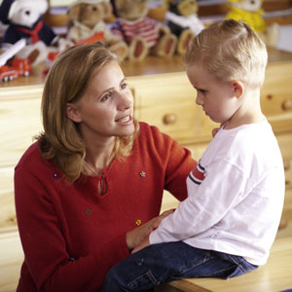
- Be careful when you say, “You did not make a good choice.” No child wakes up and says I am going to annoy the heck out of my mother today. It is usually not a conscious decision—Behave? Or Misbehave? Remember lots of the behavior from children comes WITHOUT thinking. When misbehavior happens you model the correct behavior, you redirect, you re-state the simple rule. Discipline should be progressive, with the last resort being a consequence... In doing so you are giving your child the gifts of self-love, self-respect, and confidence.
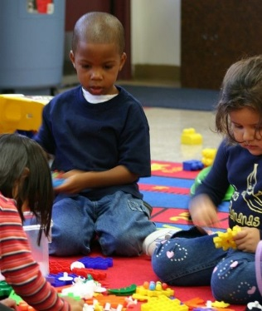
SHARING:
Change the rule, from:
- “We share our toys” TO
- “It is hard to share, you decide when you are ready to give your brother that car.”
​
By giving children time to share and letting them be in control of it, helps. After they have given the toy to someone else, now APPRECIATE it, by saying, “You are having a proud day, it is a sign of growing up to share.” Or, “You are a good friend! Good friends share!”
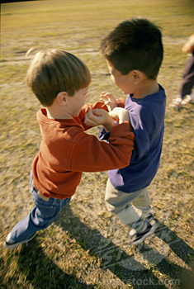
​
​
​
​
​
​
​
​

PUSHING/SHOVING:
Hands are not for hurting. Remind the children that they can only touch themselves, and if they want to touch someone they need to ask.
Then follow up with, “Do you want to push the stroller/dump truck/grocery cart?”
​
​
​
​
​
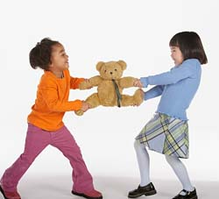
​
​
SNATCHING:
Make sure you ask the child who is taking, “Did you ask if he/she was done?” “It is polite to ask first.” Now model, “May I have that doll when you are done?” To the child who takes something from someone else, say, “Michael did you ask, John if he was done with this?” Model what Michael should say and then let him repeat it. Finish up with, “Wow Michael you are good friend.”
​
​
​
​
Remember our work as parents is important because our influence lasts a lifetime. Parenting can be a great pleasure or a dreadful burden. It is your approach that makes the difference. Laughter is required to be an effective parent and teacher. Laughing can help us cope with life’s daily demands. Maintaining a sense of humor can be a challenge on those days when the kids have gotten on your last nerve and you’re considering a career outside the home.
​
Research tells us the benefits of humor:
​
- ϖ Boosts the immune system
- ϖ Facilitates learning
- ϖ Promotes healing
- ϖ Reduces stress
- ϖ Increases creativity
- ϖ Relaxes the mind and body
- ϖ Changes behavior
- ϖ Decreases tension
- ϖ Diffuses anger... you can’t be angry and laugh at the same time!
Research estimates that laughing 100 times equals 10 minutes on the rowing machine or 15 minutes on an exercise bike. Laughing can be a total body workout!
​
Blood pressure is lowered. Laughter gives your diaphragm and abdominal, respiratory, facial, leg and back muscles a workout. That’s why you often feel exhausted after a long bout of laughter-you’ve had anaerobic workout!
​
Let’s all remember to find something each day to laugh about.
Just for today, let the kids eat dessert first.
Now that will put a smile on everyone’s face at the dinner table!
​
​
If you laugh, encourage, teach and inspire—
you’re doing it right!

